**Application Load Balancer on Lambda**

Application Load Balancers (ALBs) now support AWS Lambda functions as targets. Build websites and web applications as serverless code, using AWS Lambda to manage and run your functions, and then configure an ALB **to provide a simple HTTP/S frontend for requests coming from web browsers and clients**.

You can register your Lambda functions as targets and configure a listener rule to forward requests to the target group for your Lambda function. When the load balancer forwards the request to a target group with a Lambda function as a target, it invokes your Lambda function and passes the content of the request to the Lambda function, in JSON format.

Application Load Balancer now provides you a single HTTP endpoint for all requests whether they are served from EC2, containers, on-prem servers or Lambda functions.

With the Application Load Balancers’ support for content-based routing rules, you can also route requests to different Lambda functions based on the request content.

**Limits**

* The Lambda function and target group must be in the same account and in the same Region.
* The maximum size of the request body that you can send to a Lambda function is 1 MB. For related size limits, see [HTTP Header Limits](https://docs.aws.amazon.com/elasticloadbalancing/latest/userguide/how-elastic-load-balancing-works.html#http-header-limits).
* The maximum size of the response JSON that the Lambda function can send is 1 MB.
* WebSockets are not supported. Upgrade requests are rejected with an HTTP 400 code.

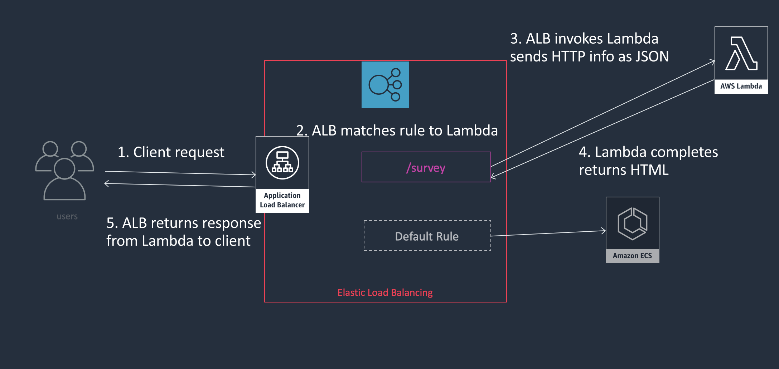

## 

## 

## **Triggering a Lambda Function from an Application Load Balancer**

To get started, you can associate Lambda functions with ALBs on the Load Balancing section of the Amazon EC2 console or on the AWS Lambda console. In the example below, we’ve chosen Application Load Balancer from the Add triggers list so we can configure a trigger for the HelloWorld Lambda function.

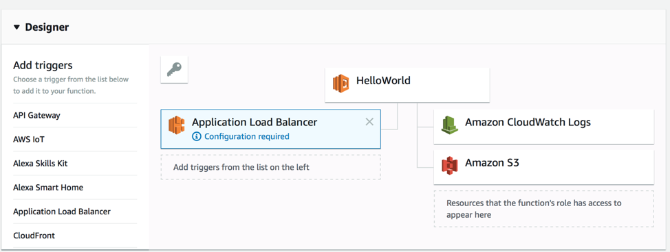

To configure the trigger, you specify which Application Load Balancer to use, and which listeners, hosts, and URL paths to forward to AWS Lambda..

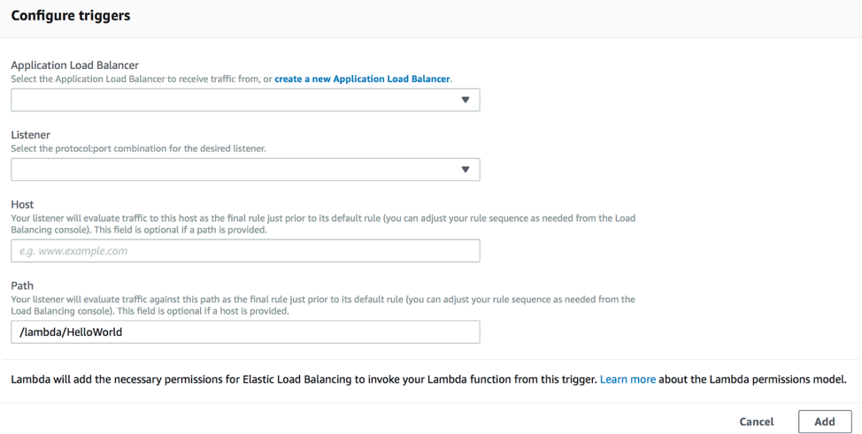

Listeners are the ports that the ALB receives traffic on. For example, there’s typically an HTTP listener on port 80 and an HTTPS listener on port 443. You can choose to send each listener to different Lambda functions, or multiple listeners can go to the same function.

When you complete the configuration, choose Add to finish your Application Load Balancer trigger setup and start forwarding the specified traffic to AWS Lambda. Now when requests that match your listener, host, and path settings arrive on the ALB, the Lambda function is invoked with an event that supplies all of details about the incoming request and load balancer.

Requests can include HTTP GET, HEAD, PUT, POST, DELETE, PATCH and OPTIONS methods, and request and response bodies can be text or binary. The Application Load Balancer that you’ve set up with AWS Lambda takes care of translating an HTTP/S request into an AWS Lambda-compatible event.

* ScreenShots of Steps to Configure 2 Lambda with Application Load Balancer

-> Create Two Lambda lambda1 and lambda2 and one application Load Balancer with aws console.

